|  |  |  |
| --- | --- | --- |
|  | **BAHRIA UNIVERSITY, (Karachi Campus)**  *Department of Software Engineering*  **Assignment 1 - Spring 2023** |  |

COURSE TITLE: **Linear Algebra** COURSE CODE: **Gsc-121**

Class: **BSE-2(A&B&C)** Shift: - Morning

Course Instructor: **Muhammad imran afridi** Time: - **2 Days**

Submission Date: **21 March 2023**  Marks: - **5 Marks**

Q1:- Find the solution set of the given system of equations by Gauss Jordon method.

$2 x_{1}-3x_{2}+2x_{3}-x_{4} = 0$

$-x_{1}+4x_{2}+2x_{3}-3x_{4}=1$

$2 x_{2}-3x_{3}+5x_{4}= -3$

Q2:- Solve the Given Circuit by Row Echelon (Gauss Elimination) form.

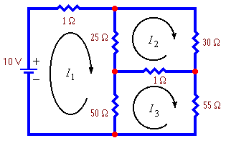

Q3:- Balance the given unbalance chemical equation by Row reduction to

Echelon form.

$$3PbN_{4}+2CrMn_{2}O_{8}→2Pb_{2}O_{3}+Cr_{2}O_{2}+2MnO_{2}+NO$$

Q4:- For what values of “h” the given “v” is a linear combination of $b_{1},b_{2}, b_{3}$

$where v=\left[\begin{matrix}h \\ 1 \\ 3\end{matrix}\right], and b_{1}=\left[\begin{matrix}3 \\ 2 \\ 0\end{matrix}\right], b_{2}=\left[\begin{matrix}-1 \\ 4 \\ 3\end{matrix}\right], b_{3}=\left[\begin{matrix}1 \\ -2 \\ 2\end{matrix}\right]$